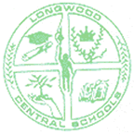
School Year:
LONGWOOD CENTRAL SCHOOL DISTRICT

K-6 INDIVIDUALIZED HOME INSTRUCTION PLAN
(IHIP)

Student Name: |  | Grade:

NYS Program Requirements in Grades Kindergarten through Six
Please describe the instructional plan for each required subject area. It is acknowledge that the subjects do not need to be developed a separate, ‘stand-alone’ portion of the pupil’s school day. They can be ‘integrated’ into another subject area.

Subject | Allotted Time (i.e., per week) | Materials/Instructional Plan
English
(include Reading, Writing, Spelling

Mathematics

Social Studies
(Include Geography, NYS and US History )

Science
(Include Life Science and Physical Science)

Health

Music

Visual Arts

Physical
Education

Electives

